WEEK 11
Working on windows 11
Exercise 1: Jenkins CI/CD using Git Webhook
Step-1: To install ngroks Go->settings->privacy and security -> windows security -> off antivirus ->
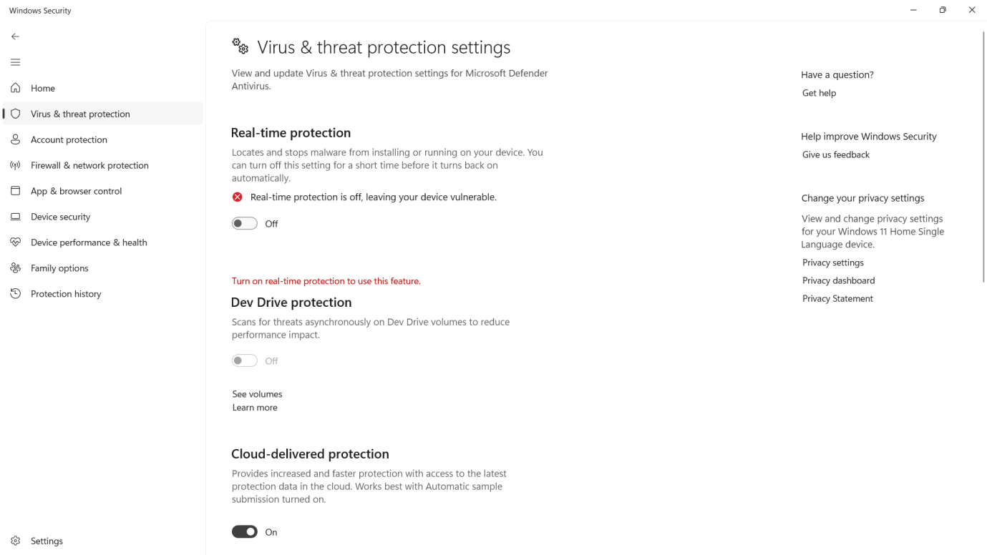

Step-2:Go -> https://ngrok.com and signup by giving your name ,email and password of atleast 10 charcaters

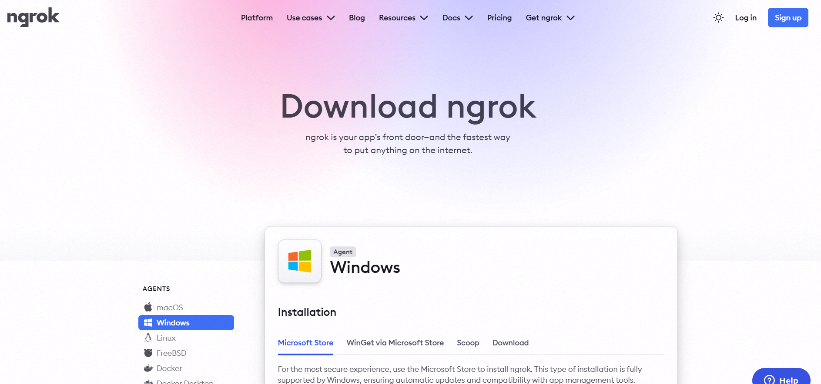

Step-3: After sign in up ,it will show below screen with your name in the top left .now click on download for windows (64Bit) to download ngork
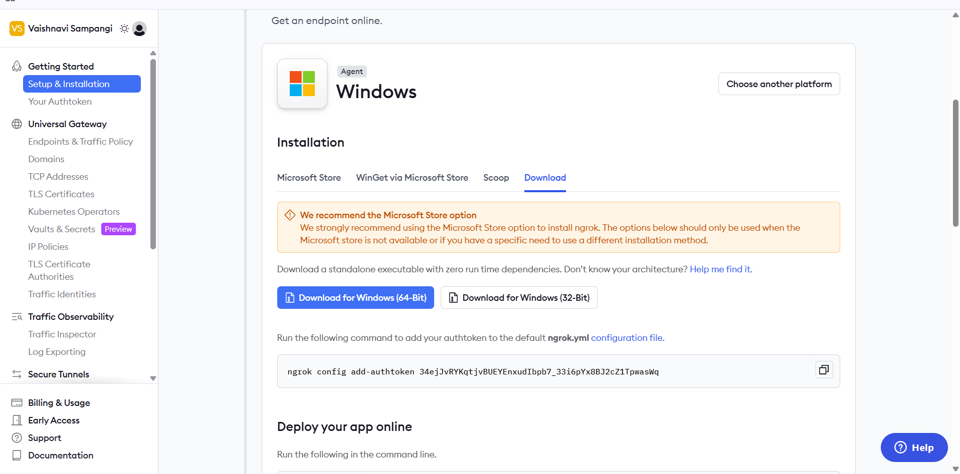

Step4:After downloading ,Extract the file and click on ngrok.exe

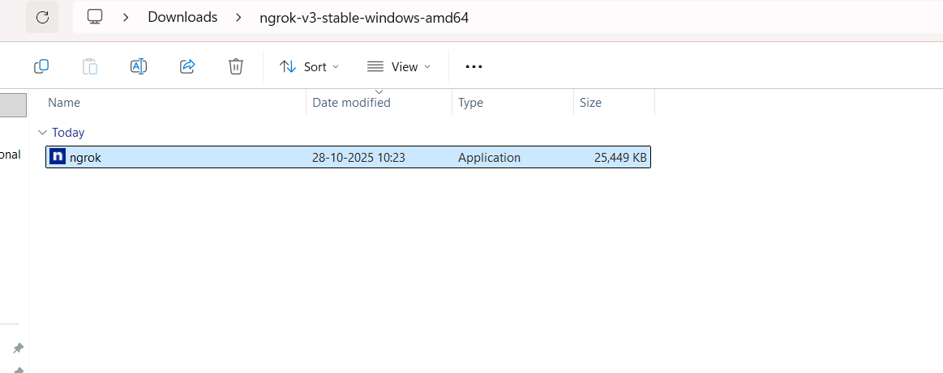

Ngrok command prompt appears as below

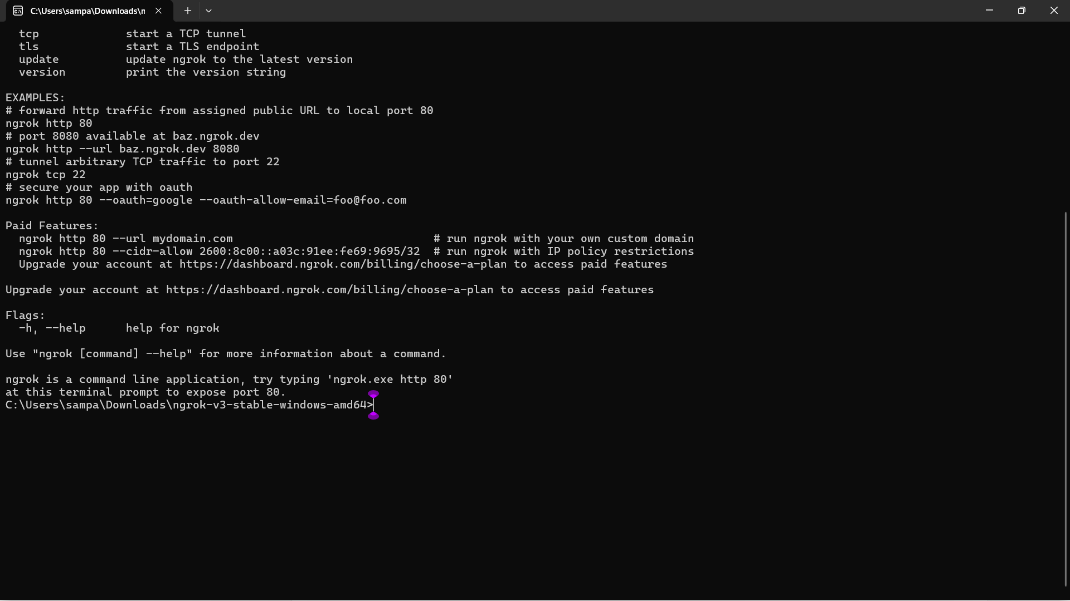
Step-5:Connect Your ngrok Account (optional but useful)
- Go to ngrok gives you an auth token.
- Then go to your Authtoken click here
- Copy your Authtoken

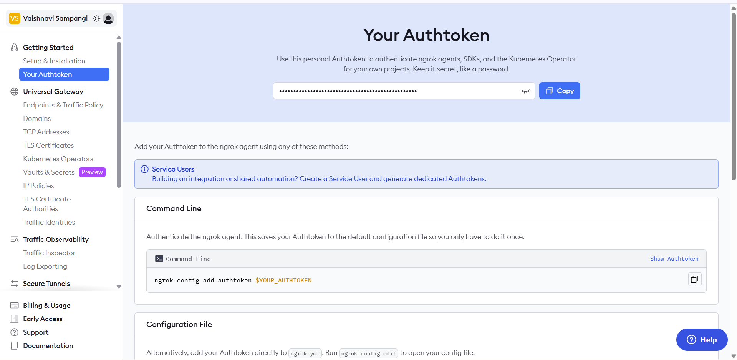

CREATE AUTHENTICATOR [https://dashboard.ngrok.com/get-started/your-authtoken]
Run this command in ngrok command prompt:(replace <your_token> with yours):

ngrok config add-authtoken <your_token> // syntax:
Example command
ngrok config add-authtoken 34ejJvRYKqtjvBUEYEnxudIbpb7_33i6pYx8BJ2cZ1TpwasWq

Step-6
Start a Tunnel for Jenkins
- Check on which port is your Jenkins running . for this give in browers or url localhost:8081
For me Jenkins is running on 8081
- Go to ngrok command prompt and type below command
- ngork http 8081 //Always use this command to start a tunnel for jenkins .

Type in ngrok command prompt:
Next it shows this public jenkins URL generated by ngrok that can be pasted into github repo for Webhooks.

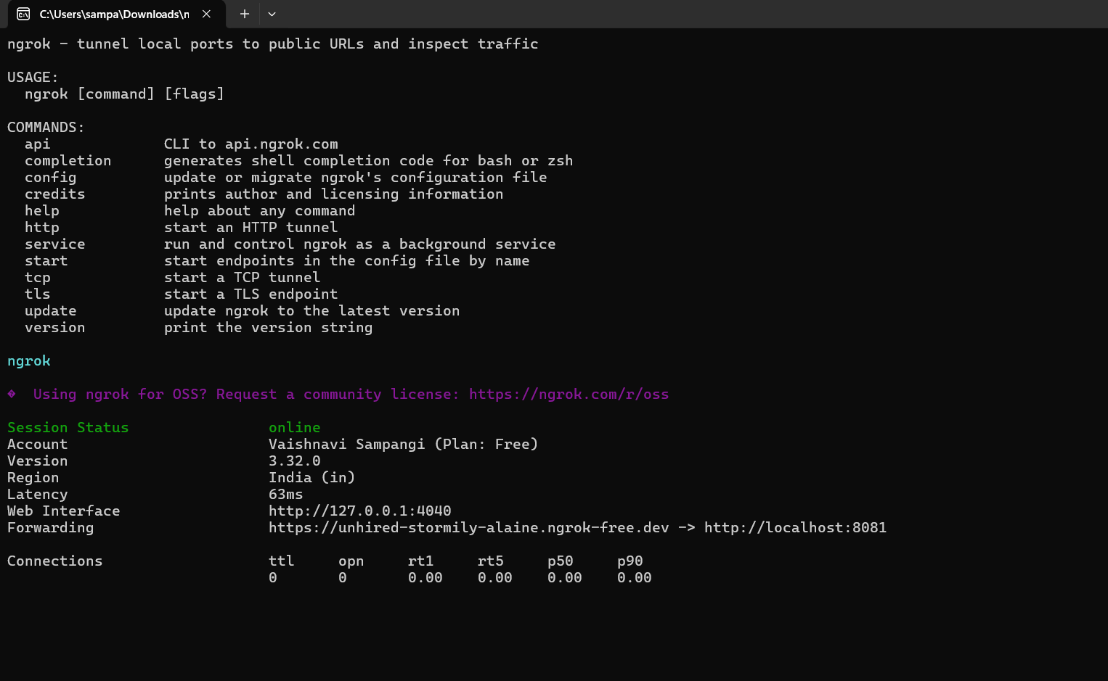

Copy this URL only highlighted part

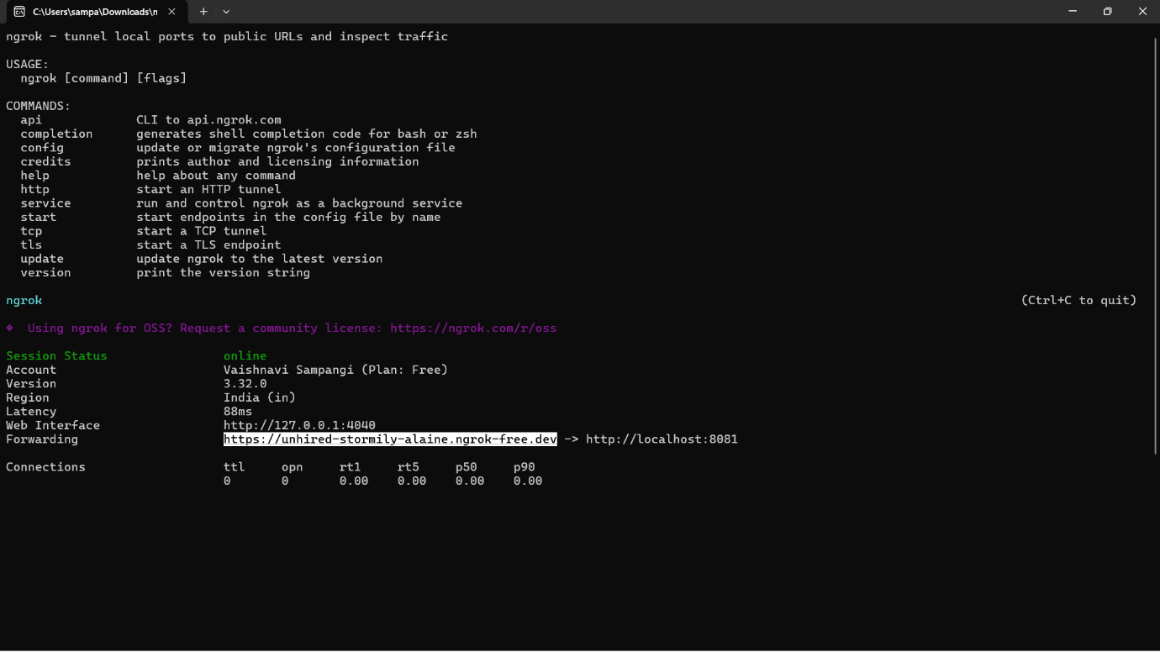

Step-7: Configure Webhook in GitHub
- Go to your GitHub repository.
- Navigate to Settings → Webhooks.
- Click “Add webhook”.
- In the Payload URL field:
  - Enter the Jenkins webhook URL in the format:
http://<jenkins-server-url>/github-webhook/
Ex: https://unhired-stormily-alaine.ngrok-free.dev/github-webhook/

Note: If Jenkins is running on localhost, GitHub cannot access it directly

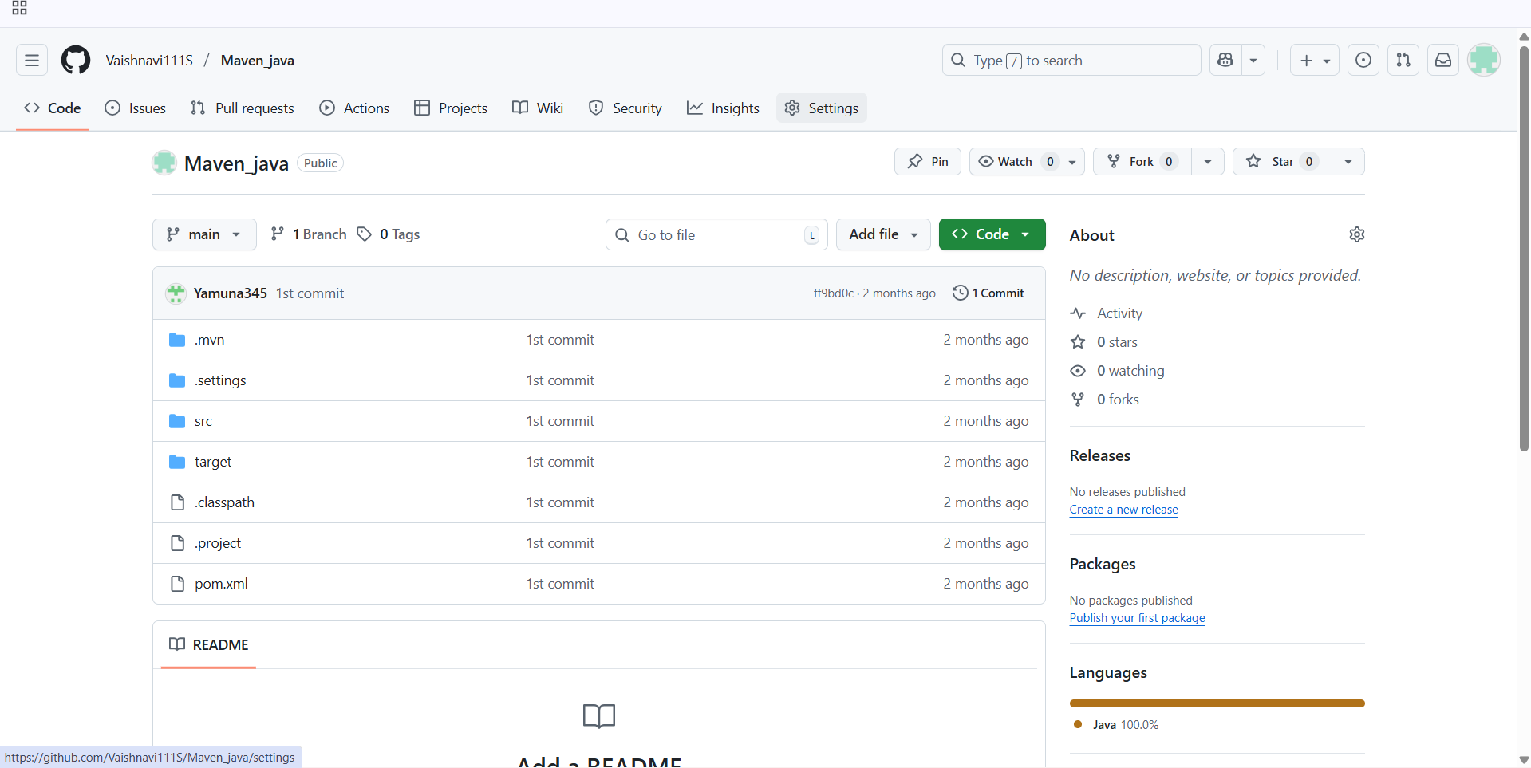
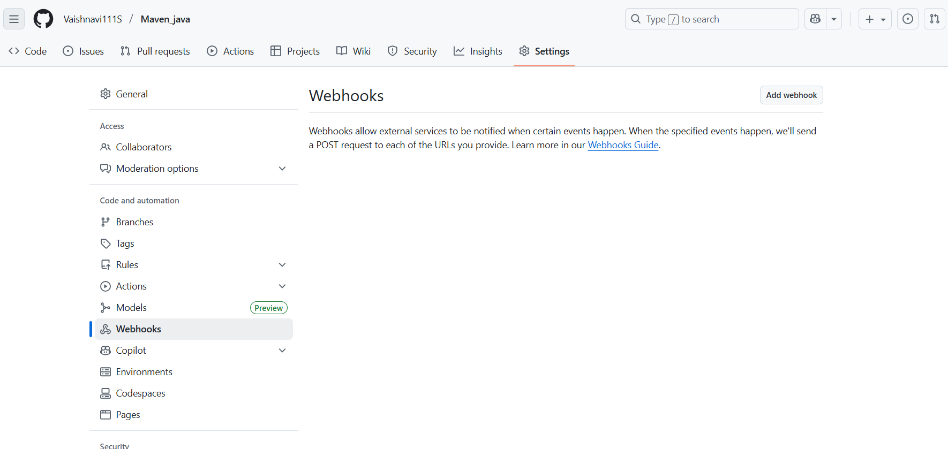

Step-8:
    - Add url https://unhired-stormily-alaine.ngrok-free.dev/github-webhook/
    - Set content Type to application/json
    - Under “Which events would you like to trigger this webhook?”, select:
Just the push event.
- Click “Add webhook” to save.

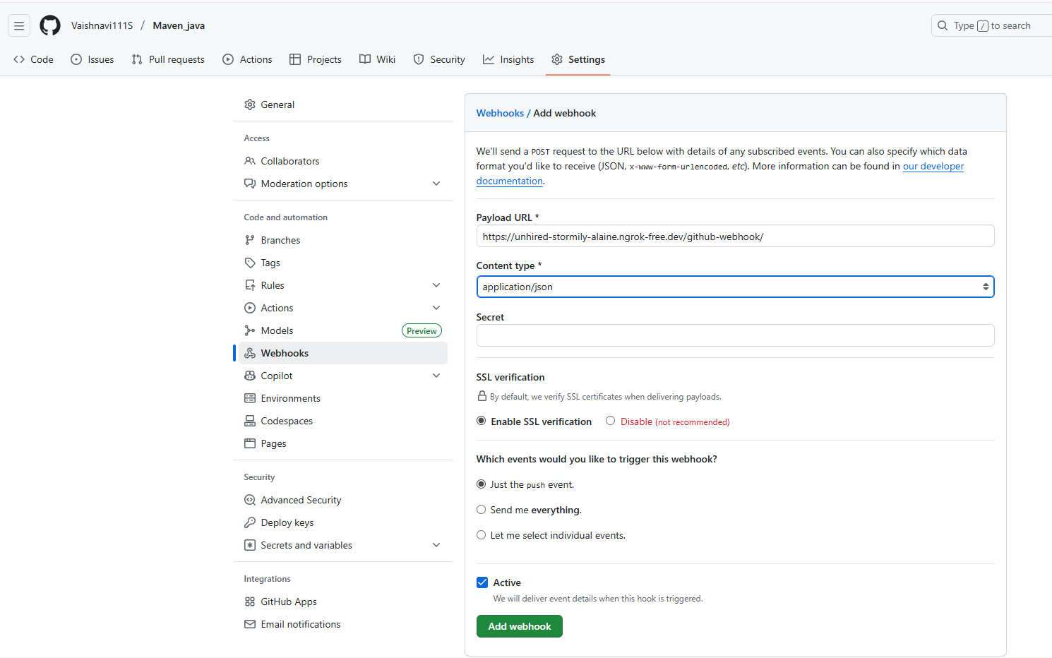

Step 10: Configure Jenkins to Accept GitHub Webhooks
- Open Jenkins Dashboard.

- Select the job (freestyle or pipeline) you’ve already created.

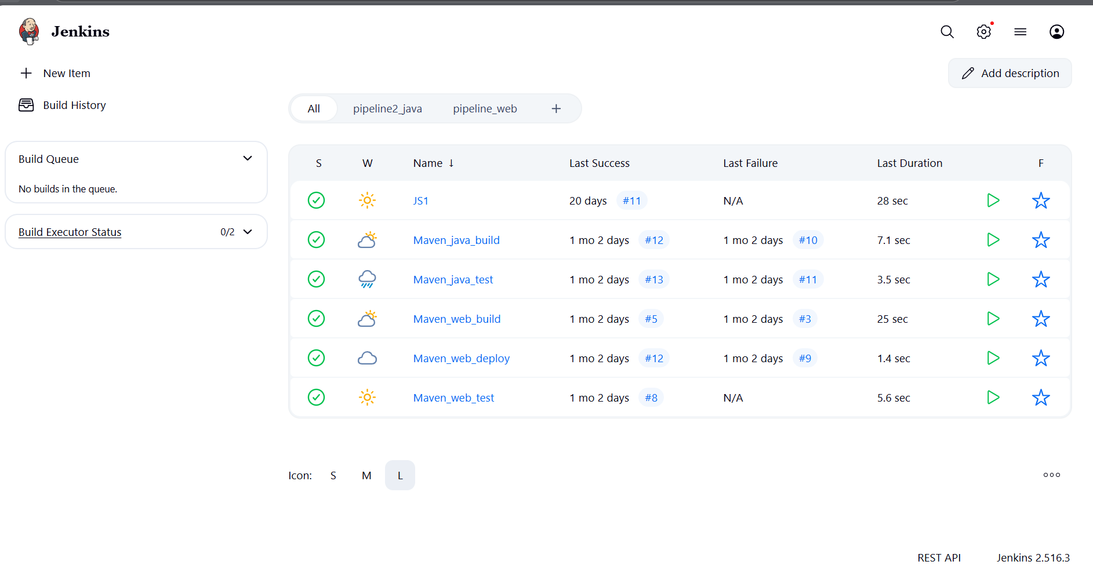
- Click Configure.
- Scroll down to the Build Triggers section.
- Check the box: ✅GitHub hook trigger for GITScm polling
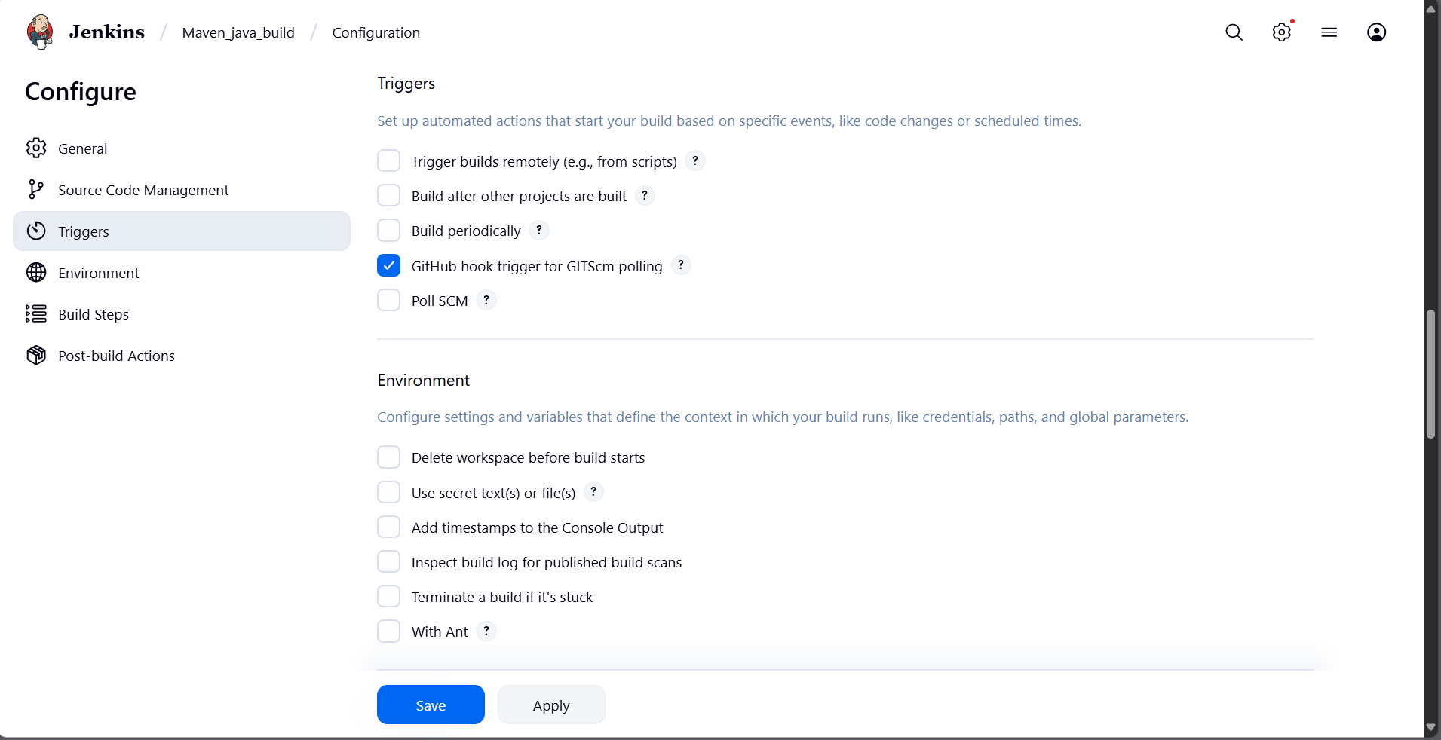
- Click Save.

Step 11: Test the Setup
- Make any code update in your local repo and push it to GitHub.
- Once pushed, GitHub will trigger the webhook.
- Jenkins will automatically detect the change and start the build pipeline.
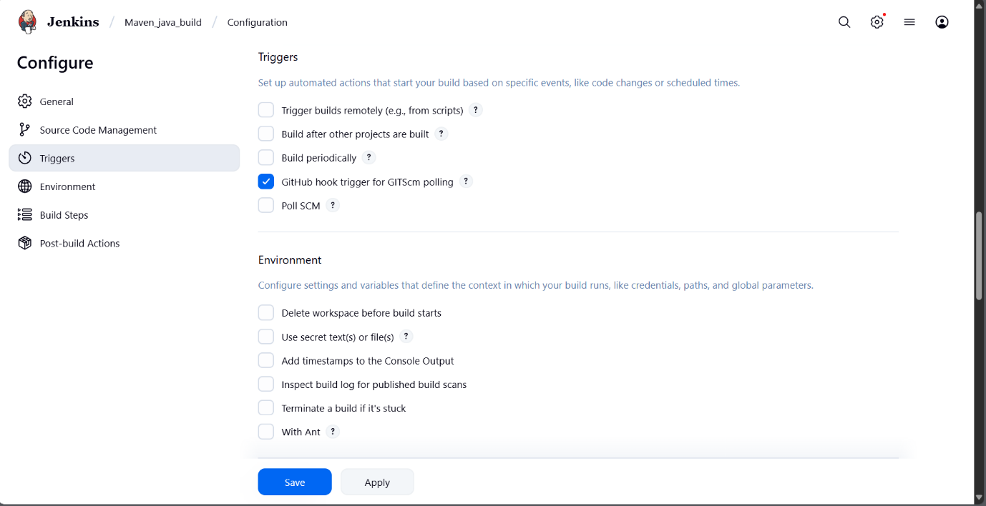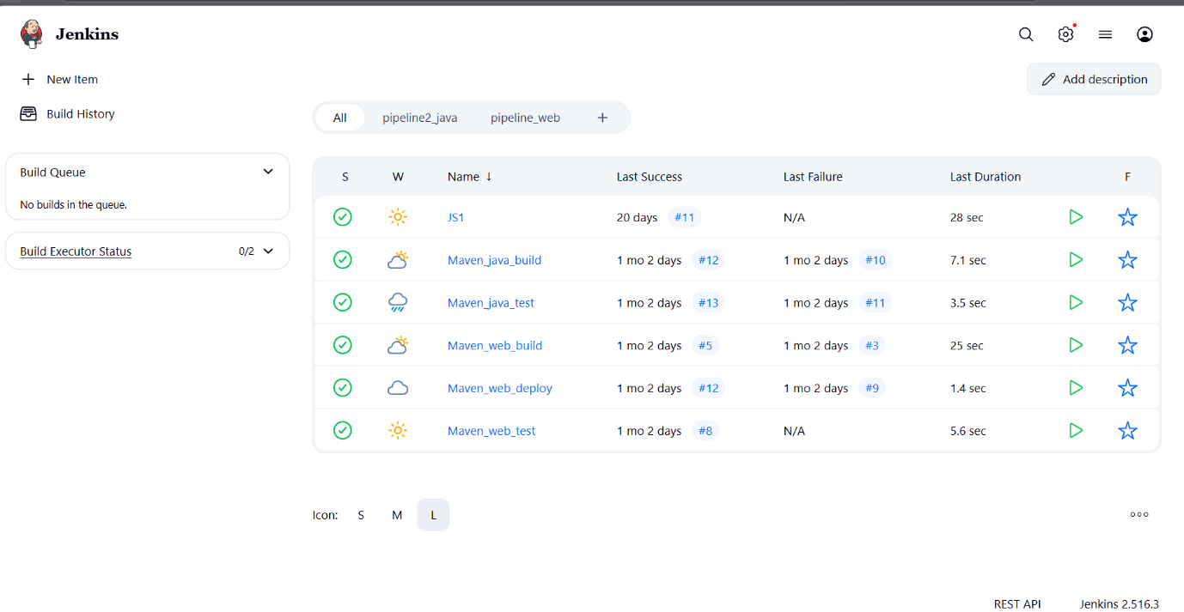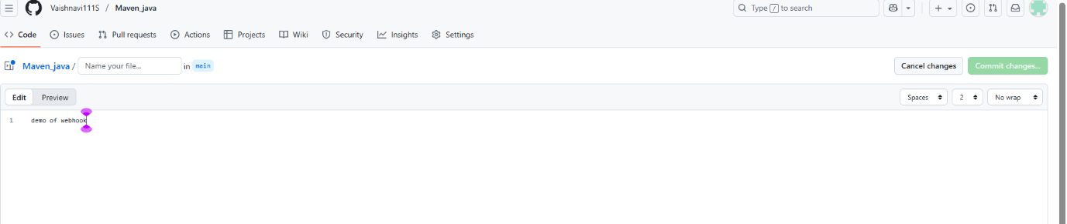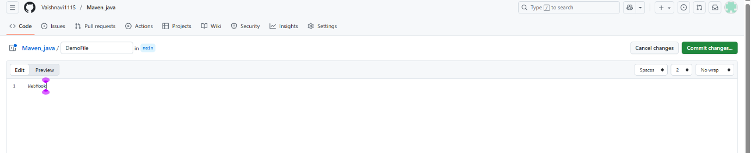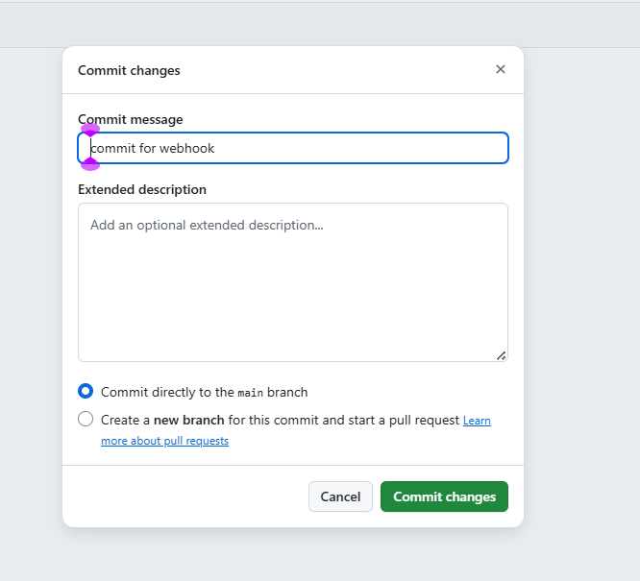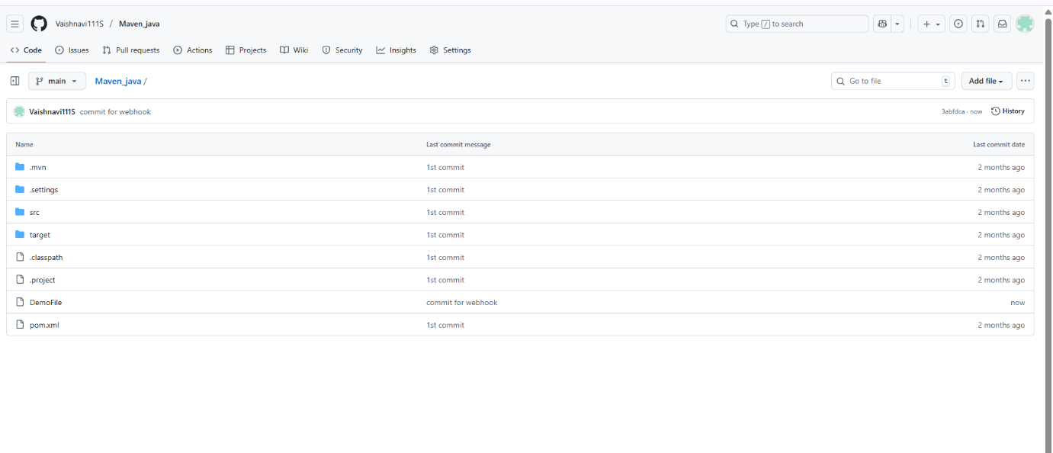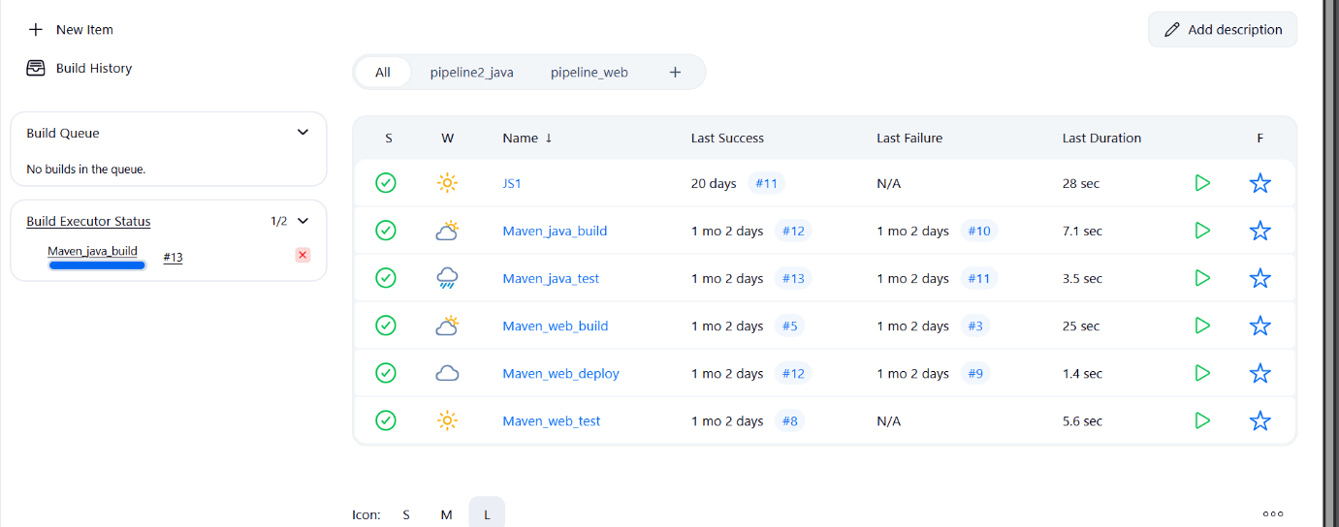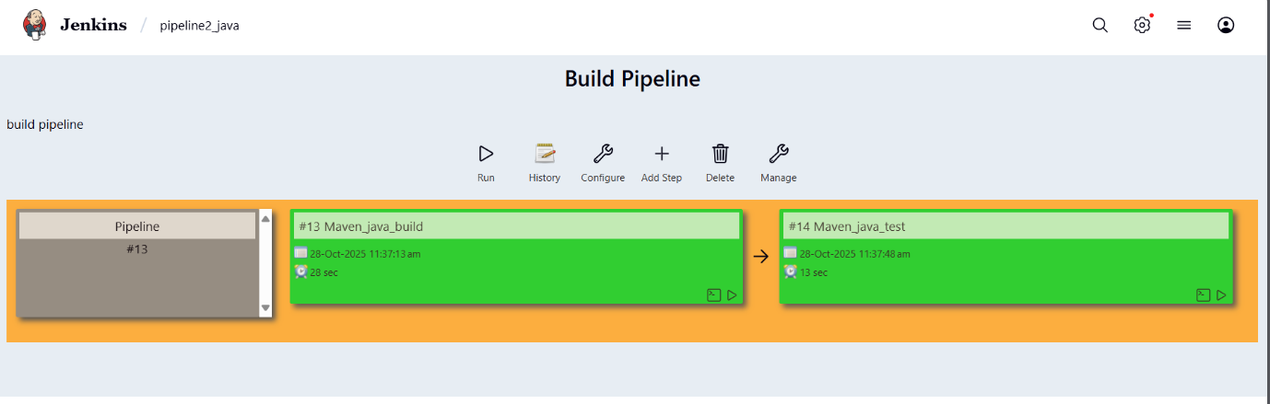

outcome
- You’ve successfully connected GitHub and Jenkins using webhooks.
- Every time you push code to GitHub, Jenkins will automatically start building your project without manual intervention.

EXCERCISE-2

Setting Up Jenkins Email Notification Setup (Using Gmail with App Password)
Creation of app password
1. Gmail: Enable App Password (for 2-Step Verification)
i. Go to: https://myaccount.google.com
ii. Enable 2-Step Verification
- Navigate to:
  - Security → 2-Step Verification
  - Turn it ON
  - Complete the OTP verification process (via phone/email)
iii. Generate App Password for Jenkins
- Go to:
  - Security → App passwords
- Select:
  - App: Other (Custom name)
  - Name: Jenkins-Demo
- Click Generate
- Copy the 16-digit app password
  - Save it in a secure location (e.g., Notepad)
2. Jenkins Plugin Installation
i. Open Jenkins Dashboard
ii. Navigate to:
- Manage Jenkins → Manage Plugins
iii. Install Plugin:
- Search for and install:
  - Email Extension Plugin

3. Configure Jenkins Global Email Settings
i. Go to:
- Manage Jenkins → Configure System

A. E-mail Notification Section
Field | Value
SMTP Server | smtp.gmail.com
Use SMTP Auth | ✅ Enabled
User Name | Your Gmail ID (e.g., archanareddykmit@gmail.com)
Password | Paste the 16-digit App Password
Use SSL | ✅ Enabled
SMTP Port | 465
Reply-To Address | Your Gmail ID (same as above)
➤ Test Configuration
- Click: Test configuration by sending test e-mail
- Provide a valid email address to receive a test mail
- ✅ Should receive email from Jenkins

B. Extended E-mail Notification Section
Field | Value
SMTP Server | smtp.gmail.com
SMTP Port | 465
Use SSL | ✅ Enabled
Credentials | Add Gmail ID and App Password as Jenkins credentials
Default Content Type | text/html or leave default
Default Recipients | Leave empty or provide default emails
Triggers | Select as per needs (e.g., Failure)

4. Configure Email Notifications for a Jenkins Job
i. Go to:
- Jenkins → Select a Job → Configure

ii. In the Post-build Actions section:
- Click: Add post-build action → Editable Email Notification
A. Fill in the fields:
Field | Value
Project Recipient List | Add recipient email addresses (comma-separated)
Content Type | Default (text/plain) or text/html
Triggers | Select events (e.g., Failure, Success, etc.)
Attachments | (Optional) Add logs, reports, etc.

iii. Click Save

Now your Jenkins job is set up to send email notifications based on the build status!

Takeaway :
Students learned how to integrate Jenkins with GitHub using webhooks to automate build triggers and configure email notifications to monitor build success or failure effectively.

